MODEL QUESTION PAPER
Code No: CS4502 | SRGEC-R23
III B.Tech I Semester Regular Examinations
FORMAL LANGUAGES AND AUTOMATA THEORY
(Computer Science and Engineering)
Time: 3 Hours Max. Marks: 70
Note: All questions from PART-A are to be answered in one place.
Answer all questions from PART-B. All Questions carry equal marks.

PART – A
10 × 2 = 20M
1. | Differences between NFA and DFA.
2. | Discuss complement of DFA.
3. | List out any eight identity rules for regular expression.
4. | Compare regular set and regular expression.
5. | Give the tuple notation for the grammar.
6. | Discuss various applications of CFG.
7. | Identify the languages accepted by the push-down automata.
8. | Differentiate between NPDA and PDA.
9. | Write a short note on importance of turing machine.
10. | Define church’s thesis.
PART – B
5 × 10 = 50M
Unit - I
 |  | BL
2. | a) Consider the following FA and check whether the strings w1= babaa w2= abbab is accepted or not. (5M)  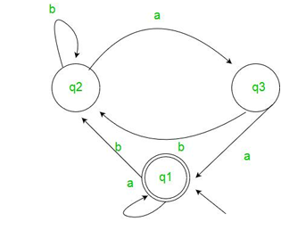  b) Define Language. Explain various operations performed on languages. (5M) | L3  L3
 | (OR)
3. | a) Explain the procedure to convert mealy machine to moore machine and illustrate with suitable example. (5M)  b) Convert the following NFA to DFA. (5M)  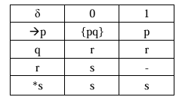 | L2  L2
Unit – II
4. | a) Construct left linear and right linear grammar for the following automata. (5M)  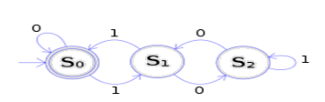  b) Show that L={a^{p} | p is prime } is not regular. (5M) | L3  L3
 | (OR)
5. | a) Prove that (1+00*1)+(1+00*1)(0+10*1)*(0+10*)=0*1(0+10*1)* (5M)  b) Construct the regular expression corresponding to the language accepted by following DFA. (5M)  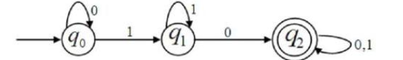 | L4  L4
Unit – III
6. | a) Classify Noam Chomsky hierarchy of grammars and languages. (5M)  b) Construct CNF for the following grammar. (5M)  S -> aAbB  A -> aA | B  B -> bB | b | L3  L3
 | (OR)
7. | Simplify the following context free grammar. (10M)  S->AB  A->BSB | BB | b | Ꞓ  B->aAb | a |Ꞓ | L4
Unit – IV
8. | a) Construct PDA for the grammar given below. (5M)  S -> SS | [S] | {S} | Ꞓ  b) Explain the procedure to design PDA. (5M) | L3  L3
 | (OR)
9. | a) Give the mathematical model of PDA. (5M)  b) Design PDA for the language L={wcw^{r}|wꞒ{a,b}*}. (5M) | L3  L3
Unit – V
10. | a) Explain various classes of P and NP, NP-Hard and NP Complete Problems. (5M)  b) Discuss various types of turing machines. (5M) | L2  L2
 | (OR)
11. | Design turning machine for L={a^{n}b^{n}c^{n}|n>=1}. (10M) | L4

